CSE 3055 Deep Learning : J Component

Slot : F2 + TF2

Team Members :

Rishabh Johri (19BDS0021)

Pragati Natwarlal Bhattad (19BCE2671)

Pratham Shah (19BCE2028)

TOPIC : Detecting Sarcasm in social media comments (Text) using re- enforcement learning)

Introduction :

Comprehending Natural language has always been tough for machines and has primarily been considered a forte of humans. Although chatbots exist and as a matter of fact are quite commonly used to automate mundane conversations like FAQs , instructions that are repetitive in nature but they lack a “human touch” . Statistically speaking , in the current scenario , 99% of the chatbots can hold a conversation without getting caught (pass the Turing Test) for just 5 minutes. All human languages are quite complex and rely on intuition. Sarcasm is one such component of Natural language that relies largely on tone , body language and heavily dependent on context and general knowledge of the world. Even humans need a lot of experience in recognizing sarcasm ( like kids take things literally). Hence it would be really interesting to work on this problem and make a genuine attempt to make machines more human.

Dataset :

1)

<https://www.kaggle.com/danofer/sarcasm>

2)

<https://www.kaggle.com/rmisra/news-headlines-dataset-for-sarcasm-detection>

Dataset description :

1) Data has balanced and imbalanced (i.e true distribution) versions. (True ratio is about 1:100). The corpus has 1.3 million sarcastic statements, along with what they responded to as well as many non-sarcastic comments from the same source. Labelled comments are in the train-balanced-sarcasm.csv file.

2)

This **News Headlines dataset for Sarcasm Detection** is collected from two news website. [TheOnion](https://www.theonion.com/) aims at producing sarcastic versions of current events and we collected all the headlines from News in Brief and News in Photos categories (which are sarcastic). We collect real (and non-sarcastic) news headlines from [HuffPost](https://www.huffingtonpost.com/).

Feasible Models:

1) RNN + LSTM (Standard choice)

2) Re- enforcement Learning models:

|  |  |  |
| --- | --- | --- |
| **Algorithm** | **Description** | **State Space** |
| SARSA - Lambda | State–action–reward–state–action with eligibility traces | Discrete |
| DQN | Deep Q Network | Continuous |
| DDPG | Deep Deterministic Policy Gradient | Continuous |
| A3C | Asynchronous Advantage Actor-Critic Algorithm | Continuous |

Rough ( basic / proto) Architecture :

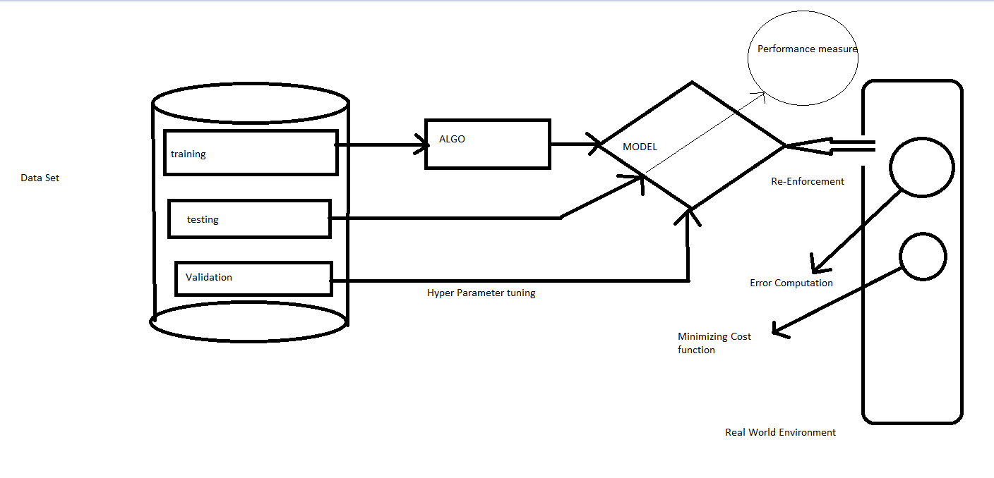

Base Papers:

1) Contextualized Sarcasm Detection on Twitter David Bamman and Noah A. Smith School of Computer Science Carnegie Mellon University {dbamman,nasmith}@cs.cmu.edu

Summary:

Sarcasm requires some shared knowledge between speaker and audience; it is a profoundly contextual phenomenon. Most computational approaches to sarcasm detection, however, treat it as a purely linguistic matter, using information such as lexical cues and their corresponding sentiment as predictive features. We show that by including extra-linguistic information from the context of an utterance on Twitter – such as properties of the author, the audience and the immediate communicative environment – we are able to achieve gains in accuracy compared to purely linguistic features in the detection of this complex phenomenon, while also shedding light on features of interpersonal interaction that enable sarcasm in conversation

2) Automatic Sarcasm Detection: A Survey ADITYA JOSHI, IITB-Monash Research Academy PUSHPAK BHATTACHARYYA, Indian Institute of Technology Bombay MARK J. CARMAN, Monash University

Summary:

Automatic sarcasm detection is the task of predicting sarcasm in text. This is a crucial step to sentiment analysis, considering prevalence and challenges of sarcasm in sentiment-bearing text. Beginning with an approach that used speech-based features, automatic sarcasm detection has witnessed great interest from the sentiment analysis community. This article is a compilation of past work in automatic sarcasm detection. Three milestones in the research so far: semi-supervised pattern extraction to identify implicit sentiment, use of hashtag-based supervision, and incorporation of context beyond target text. This article describes datasets, approaches, trends, and issues in sarcasm detection. It also discusses representative performance values, describe shared tasks, and provide pointers to future work, as given in prior works. In terms of resources to understand the state-of-the-art, the survey presents several useful illustrations—most prominently, a table that summarizes past papers along different dimensions such as the types of features, annotation techniques, and datasets used

3) Harnessing Context Incongruity for Sarcasm Detection Aditya Joshi1,2,3 Vinita Sharma1 Pushpak Bhattacharyya1 1 IIT Bombay, India, 2Monash University, Australia 3 IITB-Monash Research Academy, India aadi.cse@iitb.ac.in, [pb@cse.iitb.ac.in](mailto:pb@cse.iitb.ac.in)

Summary:

The relationship between context incongruity and sarcasm has been studied in linguistics. We present a computational system that harnesses context incongruity as a basis for sarcasm detection. Our statistical sarcasm classifiers incorporate two kinds of incongruity features: explicit and implicit. It shows the benefit of incongruity features for two text forms - tweets and discussion forum posts. The system also outperforms two past works (with Fscore improvement of 10-20%). We also show how our features can capture intersentential incongruity.

4) Sarcasm Detection on Twitter: A Behavioral Modeling Approach Ashwin Rajadesingan, Reza Zafarani, and Huan Liu Computer Science and Engineering Arizona State University {arajades, reza, [huan.liu}@asu.edu](mailto:huan.liu%7d@asu.edu)

Summary:

Sarcasm is a nuanced form of language in which individuals state the opposite of what is implied. With this intentional ambiguity, sarcasm detection has always been a challenging task, even for humans. Current approaches to automatic sarcasm detection rely primarily on lexical and linguistic cues. This paper aims to address the difficult task of sarcasm detection on Twitter by leveraging behavioral traits intrinsic to users expressing sarcasm.

5) Tweet Sarcasm Detection Using Deep Neural Network Meishan Zhang1 , Yue Zhang2 and Guohong Fu1 1. School of Computer Science and Technology, Heilongjiang University, China 2. Singapore University of Technology and Design

Summary:

Sarcasm detection has been modelled as a binary document classification task, with rich features being defined manually over input documents. Traditional models employ discrete manual features to address the task, with much research effect being devoted to the design of effective feature templates. This paper investigates the use of neural network for tweet sarcasm detection, and compare the effects of the continuous automatic features with discrete manual features. In particular, it uses a bi-directional gated recurrent neural network to capture syntactic and semantic information over tweets locally, and a pooling neural network to extract contextual features automatically from history tweets. Results show that neural features give improved accuracies for sarcasm detection, with different error distributions compared with discrete manual features.

Link to papers and Data :

<https://github.com/rishabhjohri/SarcasmDetection_renforcementlearning>